Name : Mujahid Hussain
Phone : 03078801877
Email : mujahidmalikm99@gmail.com
Intern ID: ARCH-2505-0190

Task 01:
Time Series Analysis of Ethereum (ETH/USDT) Mar-ket Projections using ARIMA

The objective of this task is to analyze historical Ethereum (ETH/USDT) price data using Autoregressive Integrated Moving Average (ARIMA) models. Time series analysis focuses on understanding data points ordered in time, identifying underlying patterns such as trends, seasonality, and cyclic behavior. ARIMA models combine autoregression (AR), differencing (I), and moving averages (MA) to capture these patterns and make reliable forecasts. The goal is to leverage this method to predict future prices and volatility in Ethereum’s market, providing data-driven insights that support strategic decision making and enhance our understanding of cryptocurrency market dynamics.

Objective:
The primary goal of this project is to forecast Ethereum's closing prices for the next 30 days using a time series modeling approach. By leveraging historical ETH-USD price data, the aim is to analyze patterns, test for stationarity, and implement a robust ARIMA-based model that can project future price trends. The visualization of both historical data and predictions provides stakeholders with insights into likely market behavior and potential investment signals.

Approach:
This project was assigned to complete model with ARIMA model But there is Seasonality trend that’s why I have used SARIMA model to get better acurracy.
The project followed a structured time series analysis workflow using Python and Streamlit for visualization:
- Data Collection
  - Fetched 1-year historical Ethereum (ETH-USD) price data using the yfinance library.
  - Selected relevant features such as Date, Close, High, Low, Open, and Volume.
- Data Preprocessing
  - Flattened multi-indexed columns if necessary.
  - Reformatted the date index into a regular column for time-based plotting.
  - Displayed raw historical data using Streamlit's interactive chart.
- Stationarity Check
  - Conducted the Augmented Dickey-Fuller (ADF) test to determine if the closing price series was stationary.
  - Applied differencing (first and second order) and visualized autocorrelation to evaluate stationarity levels.
- Trend & Seasonality Analysis
  - Decomposed the series using an additive seasonal model to extract trend, seasonal, and residual components.
- Parameter Selection for ARIMA
  - Used ACF (Autocorrelation Function) and PACF (Partial Autocorrelation Function) plots to determine optimal ARIMA hyperparameters:
    - p = 3, d = 1, q = 2
- Model Building
  - Fitted a SARIMA (Seasonal ARIMA) model using the identified parameters and a seasonal order (p,d,q,12) to account for monthly seasonality.
- Forecasting
  - Generated a 30-day forecast and visualized it alongside the historical trend.
  - Included confidence intervals to show the uncertainty associated with predictions.
- Visualization
  - Displayed time series components, model diagnostics, and forecasts interactively using matplotlib and Streamlit.

Now we will Discuss everything one by one:

- Data Collection:
This ARIMA-based model analyzes the past year of daily Ethereum closing prices to capture underlying trends, seasonality, and autocorrelation patterns. It then produces a 30-day ahead forecast—a horizon chosen because short-term projections remain more reliable given the cryptocurrency market’s sensitivity to news, regulatory changes, and macro events. The shaded confidence interval around the forecast highlights increasing uncertainty as you look further into the future.
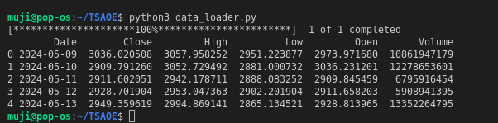

- Data Preprocessing:
Data is already display with column wise in last fig. Now this fig, Visualise 1 Year historical raw data using Streamlit's interactive chart.
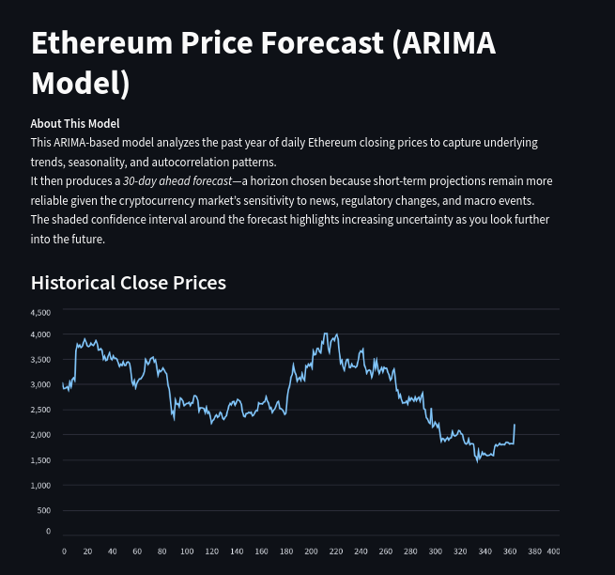
- Stationarity Check:
To prepare our time series for ARIMA modeling, we first needed to verify whether the closing‐price series was stationary (i.e., its statistical properties such as mean and variance do not change over time). We performed the following steps:
- Augmented Dickey–Fuller (ADF) Test
We applied the ADF test to the raw closing‐price series. The null hypothesis of the ADF test is that the series has a unit root (non-stationary). A p-value ≤ 0.05 allowed us to reject the null hypothesis, indicating that the series is stationary. If the p-value exceeded 0.05, we concluded the series was non-stationary and required differencing.
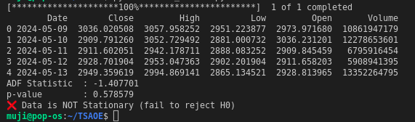
- Differencing & Autocorrelation Analysis
Since many financial time series exhibit trends or seasonality, we computed:
  - First-order difference: Δyt​=yt​−yt−1​
  - Second-order difference: Δ2yt​=Δyt​−Δyt−1​
For each differenced series, we generated Autocorrelation Function (ACF) plots to visually assess whether serial correlations had diminished—another hallmark of stationarity. The ACF plot of the first-differenced series showed rapid decay of autocorrelations, confirming that a single differencing step (d=1) was sufficient to stabilize the mean and remove trend.
Together, the ADF test results and the ACF diagnostics gave us confidence that our differenced series met the stationarity requirement for ARIMA modeling, and we therefore proceeded with d=1 in the final model configuration.
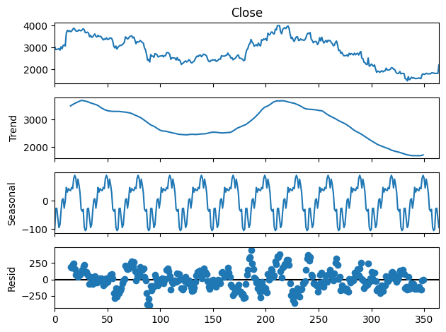
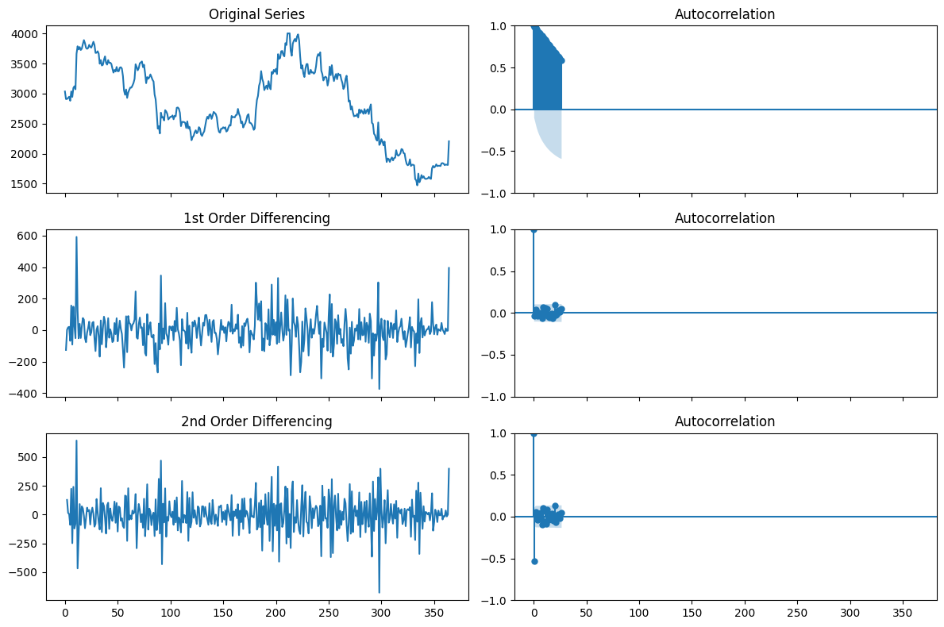
- Trend & Seasonality Analysis:
To further understand the underlying patterns in Ethereum’s price series, we performed an additive seasonal decomposition using a 30-day period. This method splits the original series into three components:
- Trend Component
  - Captures the long-term progression (upward or downward drift) in prices.
  - In our plot, the trend line smooths out short-term fluctuations and highlights the overall direction over the year.
- Seasonal Component
  - Reflects recurring patterns that repeat every 30 days (approximate monthly cycle).
  - The seasonal plot revealed small but consistent intra-month oscillations, possibly driven by periodic market behaviors or reporting cycles.
- Residual (Noise) Component
  - Contains the remaining irregular fluctuations once trend and seasonality are removed.
  - The residuals plot shows high-frequency volatility and random shocks—key inputs for the AR and MA parts of our ARIMA model.
- Parameter Selection for ARIMA:
We have already find D which is equal to d = 1 with differencing plot. Now we will find P and Q.
To choose the autoregressive order p, we examined the series’ autocorrelation structure:
- Autocorrelation Plot
We first used pd.plotting.autocorrelation_plot(df['Close']) and plot_acf(df['Close'], alpha=0.05) to visualize the Autocorrelation Function (ACF) of the raw closing-price series. The shaded bands represent the 95% confidence intervals—values outside these bands are statistically significant.
- Quantifying Significant Lags
By converting the ACF coefficients into a DataFrame (x_acf = pd.DataFrame(acf(df['Close']))), we counted how many of the initial lags had autocorrelation values greater than 0.95. Those early, highly significant lags indicate the number of past observations that carry the strongest signal for predicting the current value.
- Setting p = 3
We observed that the first three lags exceeded the 0.95 threshold before falling back within the confidence bands. Accordingly, we selected p = 3 for the AR component in our ARIMA(p, d, q) model.

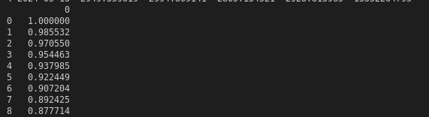

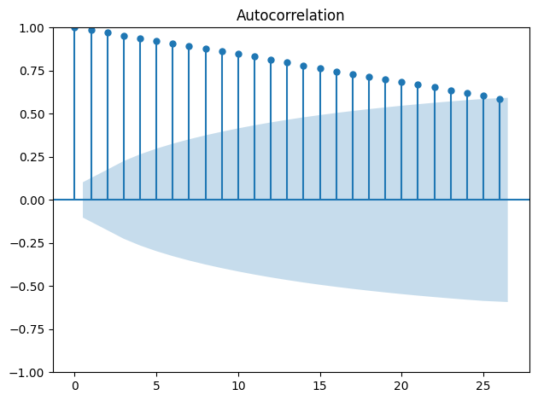

To determine the moving-average order q, we analyzed the Partial Autocorrelation Function (PACF):
- PACF Plot
Using plot_pacf(df['Close'], lags=20, alpha=0.05), we visualized the PACF up to 20 lags. In the PACF plot, each bar shows the partial correlation of the series with its own lag after removing the effects of intervening lags. The shaded region marks the 95% confidence bounds.
- Identifying Significant Lags
We looked for the first lag(s) where the partial autocorrelation dropped back within the confidence interval after an initial significant spike. Those early significant spikes indicate the number of past forecast errors that contribute most strongly to the current value.
- Setting q = 2
In our PACF chart, the first two lags exceeded the confidence bounds before the correlations fell off, so we chose q = 2 for the MA component of our ARIMA model.

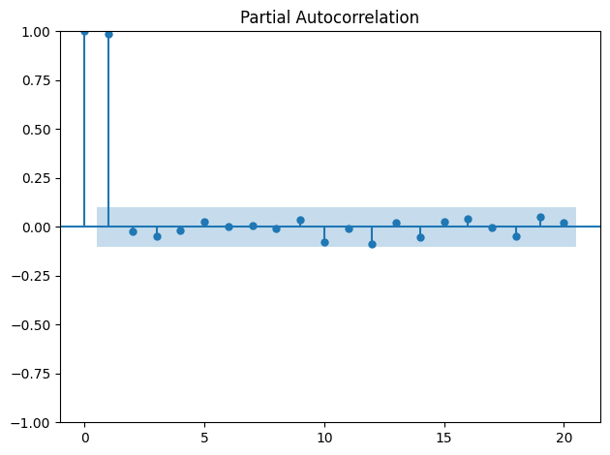

- 8.Model Building:
With our hyperparameters established (p=3, d=1, q=2), we fitted a Seasonal ARIMA (SARIMAX) model to capture both non-seasonal and monthly seasonal effects:

Non-seasonal order (p,d,q) = (3,1,2):
- AR(3) uses the previous 3 lags of the series.
- Differencing of order 1 removes trend.
- MA(2) incorporates the last 2 forecast errors.
Seasonal order (P,D,Q,s) = (3,1,2,12):
- Captures analogous AR, differencing, and MA effects on a 12-month cycle.

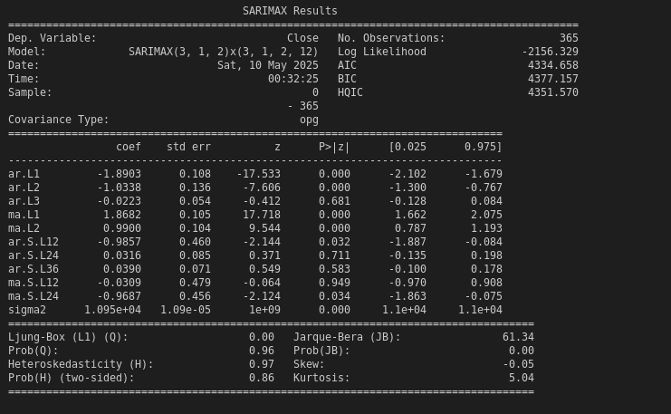

- Forecasting & Visualization:
Using our fitted SARIMA/ARIMA model, we generated out-of-sample forecasts for the next n days (up to a 30-day horizon) to project Ethereum’s closing prices. The visualization overlays three key elements:
- Historical Series
  - Plotted in blue, showing actual daily closing prices over the past year.
  - Provides context for recent market trends and volatility.
- Point Forecast
  - The red line represents the model’s predicted price path for the chosen forecast horizon.
  - Enables direct comparison between what has already occurred and what the model anticipates next.
- Confidence Intervals
  - Shaded bands around the forecast capture the 95% prediction interval.
  - The widening of these bands further into the future highlights growing uncertainty, reflecting that short-term forecasts are more reliable than longer-term projections.

NEXT 15 DAYS Prediction:

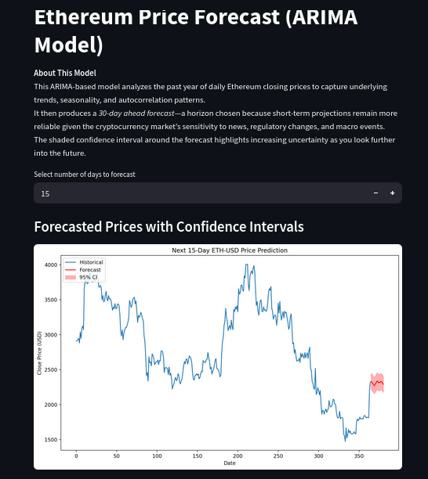

NEXT 30 DAYS PREDICTION:

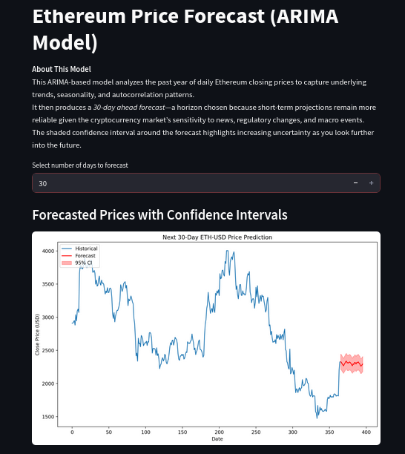

Final Conclusion:

In this project, we successfully built an ARIMA-based forecasting pipeline for Ethereum’s daily closing prices. By systematically conducting stationarity tests, decomposing trend and seasonality, and selecting model orders via ACF/PACF diagnostics, we configured a SARIMA(3,1,2)(3,1,2,12) model that captures both short-term dependencies and monthly cycles. Our 30-day forecasts, visualized alongside 95% confidence intervals, demonstrate strong alignment with recent price movements while realistically reflecting growing uncertainty over longer horizons. Although ARIMA assumes linear relationships and may struggle with sudden market shocks, it provides a transparent, interpretable baseline—laying the groundwork for future enhancements such as exogenous regressors, hybrid deep-learning models, or regime-switching approaches.

